Graph QR code size vs camera resolution vs distance Tom One day
Check QR codes don't conflict with YOLO Tom Half day

Decide on vision system: Both
QR Dan Undefined
YOLO Both Undefined
Implement identification solution
Combine solution with depth map for xyz localisation
know when object is identified, check for false positives

Research, development and testing has to be done on the cascaded vision systems as they have conflicting requirements.
Problem:
We are still uncertain of the methods we will use for identifying and localising objects with each camera system.
Head camera:
Our options for the head camera are YOLO or fiducials. YOLO is a neural-network based realtime object detection and localisation system. It identifies and localises objects in a camera feed or still picture. Is we use YOLO for the head camera, we will modify the program found here (https://github.com/pjreddie/darknet/wiki/YOLO:-Real-Time-Object-Detection) to return the CofM of the identified objects. This CofM will then be located in the RGBD image stream from the kinect, where the depth value of the identified object will be calculated and thus the location of the object will be known. Development has not yet started on this solution and only preliminary research has been done to assess the feasability of making this system.

The other option for the head camera is fiducials. If we use this approach, QR codes will be attached to the object we wish to recognise. If a fiducial is seen in a camera feed, the location of the fiducial can be calcualted.

Hand camera:
Fiducials are a better option for the hand camera as YOLO must see the entire object to identify it. As the gripper closes in on an object, the objects apparent size will increase until the edges of the object are no longer visable. When this happens it becomes impossible to calculate the CofM of the object and thus the gripper cannot be properly aligned to grasp the object.

A small QR code on the object could be used to guide the hand camera. The extent to which placing a QR code for the hand camera on the object will obscure the YOLO identification is currently unknown.

The hand camera requires the fiducial to be small in order to be detectable at close range, whereas the head camera requires the fiducial to be large in order to identify the object at long range. The gripper will have a maximum size of object that it can pick up. It is possible that a fiducial covering an entire face of the largest object that the gripper can grasp may not be large enough to detect at a range of more than 1.5 meters.

Another option to address both systems is fractal fiducials as can be seen in image XXXX [1]. This would allow the head camera to see the object far away whilst providing the hand camera with smaller fiducials to track. The data in each sub-fiducial can contain the fiducials coordinate and level within the larger fidicial. Again, only preliminary research has been done into the feasability of this approach
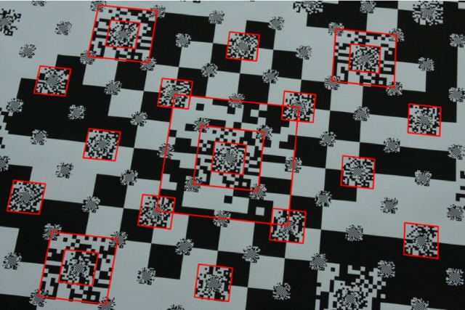

A high priority in the early stages of our project development is to find out how well we can idenfity fiducials at a distance. Data on camera resolution, fiducial size and distance to fiducial will be collected for both camera systems and a graph will be generated for both regular and fractal fiducials. From this we will be able to see which approach (or combination of approaches) will be most suitable.
Bad res/distance:
If the graph shows that the size of fiducial required for the headcam to detect is larger than the largest object the gripper can pick up, then we will look into higher resolution head cameras. If, with high resolution cameras, it is still not possible to detect objects at a reasonable range, then the scope of the project will have to be quickly reevaluated.

Reasonable res/distance:
Fractal QR codes and YOLO localisation in 3D will be investigated further to find the relative reliability and feasability of each approach with emphesis on reducing required development time and finding a robust solution.

[1]A. Herout, M. Zachariáš, M. Dubská and J. Havel, "Fractal marker fields: No more scale limitations for fiduciary markers," 2012 IEEE International Symposium on Mixed and Augmented Reality (ISMAR), Atlanta, GA, 2012, pp. 285-286.
doi: 10.1109/ISMAR.2012.6402576
keywords: {augmented reality;cameras;fractals;image motion analysis;FMF;QR-code;camera motion;camera-based augmented reality;data matrix;embedding marker;fiduciary marker;fractal marker field;fractal structure;marker constant density;marker field surface;matrix code;Augmented reality;Calibration;Cameras;Fractals;Image color analysis;Manganese;Reliability},
URL: http://ieeexplore.ieee.org/stamp/stamp.jsp?tp=&arnumber=6402576&isnumber=6402509

